COSC 3364 – Principles of Cybersecurity

Lab 03

Signed Digital Envelope

Ethan Conner

Lab 03

1. Develop a program to generate a signed digital envelope utilizing RSA for the asymmetric encryption of the symmetric key & digital signature, AES in CBC mode for the symmetric encryption of the message, and SHA256 for the hash function.

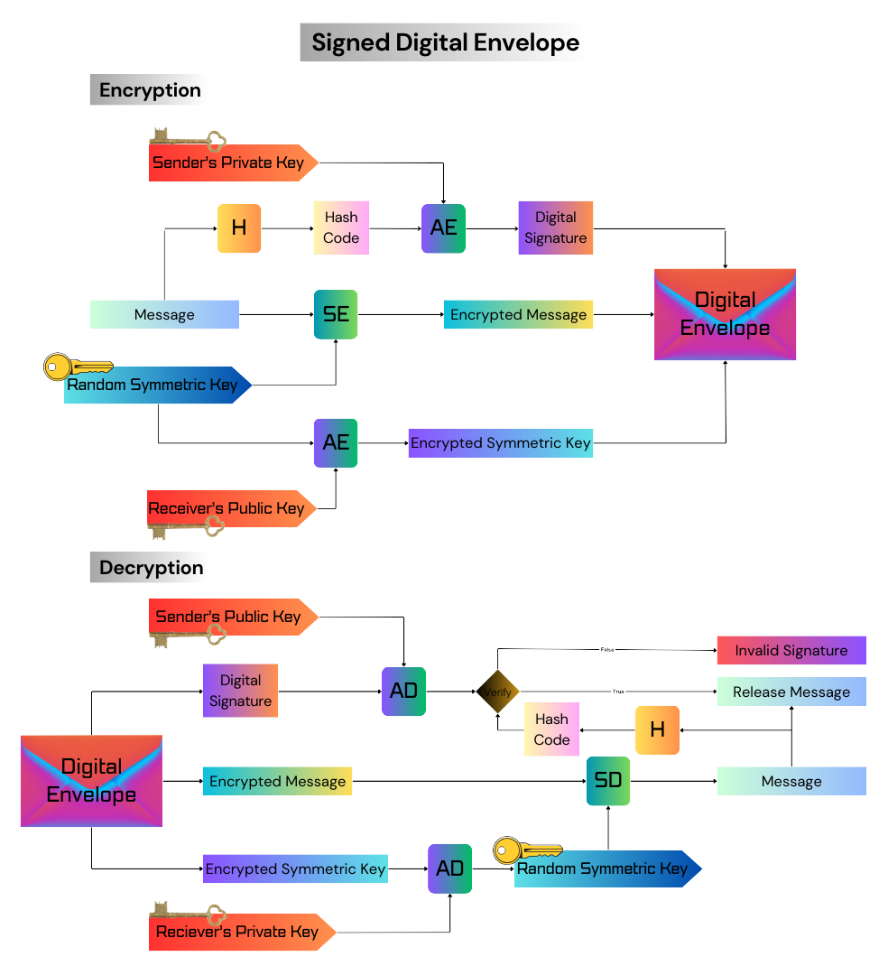

**ANSWER IN SCREENSHOTS BELOW**

**Output Screenshots**

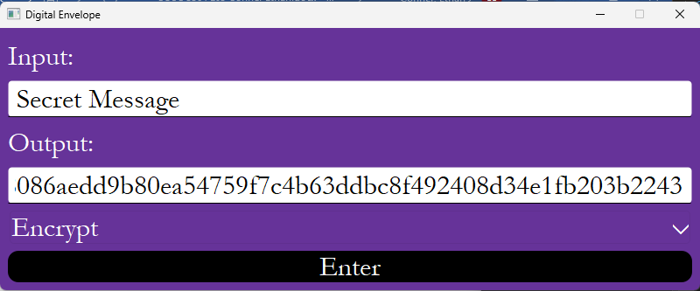

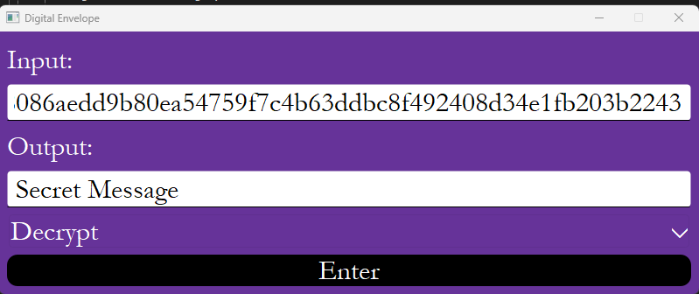

I attached my .py file to the submission.

AES

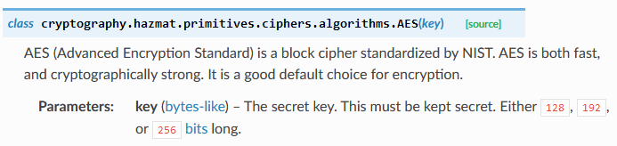

RSA

RSA Encryption

RSA Decryption

RSA Signing

RSA Verification

SHA-256

CBC

PSS

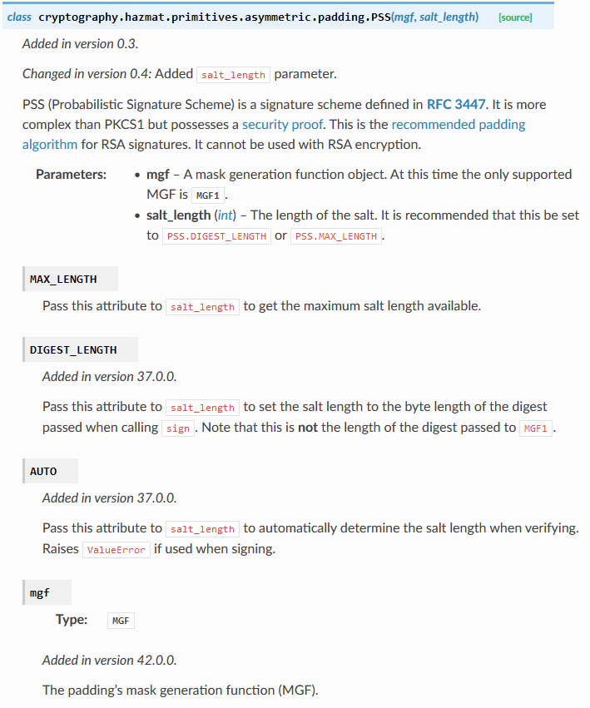

MGF1

OAEP

PKCS7

InvalidSignature Exception

